**Year 9 Chemical Reactions Test Revision**

1. What are the three subatomic particles that make up an atom? What is the electrical charge on each particle?

Proton (positive +), Electron (negative -) and Neutron (neutral 0)

1. What does the atomic number of an element say about the subatomic particles in its atoms?

Atomic number is the number of protons in the nucleus, it also determine what element it is.

1. What is the relationship between the number of protons and electrons in a neutral atom?

In a neutral atom the number of protons and electrons are equal.

1. Explain the difference between a neutral and a charged atom.

Neutral atom has equal protons and electrons, charged atoms have a different number of protons and electrons.

1. Which subatomic particles are included in the atomic weight? Why is the other particle not included?

Protons and neutrons are included in atomic weight. Electrons are not included because their weight is so small.

1. What relative scale is used to measure the mass of subatomic particles? Why is it used?

AMU atomic mass units is used because mass of proton and neutron is so similar.

1. 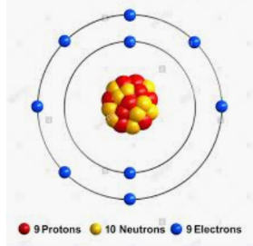Draw a labelled diagram of an atom with an atomic number of 9 and a mass of 19.
2. Write an atomic symbol for the atom you drew in question 7.

19

F

9

1. What is an isotope? Use an example as part of your answer.

Isotope is an atom of the same element with a different number of neutrons. For example Carbon-12 and Carbon-13 have 6 and 7 neutrons.

1. Draw electron configuration diagrams and write the shorthand configuration of the following elements.
   1. 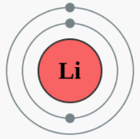Lithium
   2. 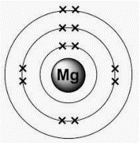Magnesium
   3. 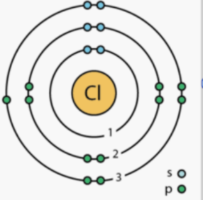Chlorine
   4. 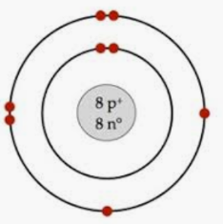Oxygen
   5. 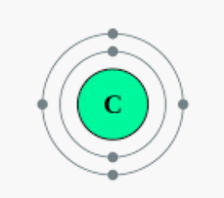Carbon
   6. 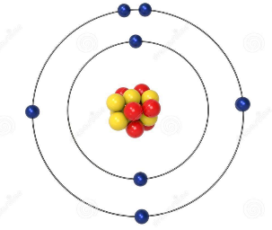Nitrogen
2. How is a flame test conducted?

By heating a solution containing a metal over a Bunsen burner.

1. What does a flame test show, and how is that useful to scientists?

Flame tests show different colours when heated, it can help distinguish between two very similar looking substances.

1. Explain what is happening to the electrons during a flame test.

The electrons in the outer shell gain energy and get excited, they then jump to an empty shell further out. When they return back to their original shell photons/coloured light is released.

1. For each of the following reactions, write a **word equation** to describe the reaction.
   1. Iron metal reacts with oxygen to form iron oxide, or rust.

Iron + oxygen 🡪 iron oxide

* 1. Sodium hydroxide is mixed with nitric acid to form water and sodium nitrate.

Sodium hydroxide + nitric acid 🡪 water + sodium

* 1. Lead oxide is formed when lead reacts with oxygen.

Lead + oxygen 🡪 lead oxide

* 1. Sulphuric acid is poured over magnesium metal to produce hydrogen gas and magnesium sulphate.

Sulphuric acid + magnesium 🡪 hydrogen + magnesium sulphate

* 1. Sodium and water react together to form sodium hydroxide and hydrogen gas.

Sodium + water 🡪 sodium hydroxide + hydrogen

1. Balance each of the **formula equations** below by putting coefficients in front of the formulae. Show your working in the spaces below.
   1. Zinc + Oxygen 🡪 Zinc oxide

2 Zn + O2 🡪 2 ZnO

Zn = 2 Zn = 2

O = 2 O = 2

* 1. Calcium oxide + Hydrochloric acid 🡪 Calcium chloride and water

CaO + 2HCl 🡪 CaCl2 + H2O

Ca = 1 Ca = 1

O = 1 O =1

H = 2 H =2

Cl = 2 Cl =2

* 1. Methane + Oxygen 🡪 Water + Carbon dioxide

CH4 + 2 O2 🡪 2H2O + CO2

* 1. Magnesium + Sulphuric acid → Magnesium sulphate + Hydrogen

Mg + H2SO4 🡪 MgSO4 + H2

Already balanced

* 1. Iron + Oxygen 🡪 Iron oxide

4Fe + 3 O2 🡪 2 Fe2O3

* 1. Sulphuric acid + Sodium → Sodium sulphate + Hydrogen

H2SO4 + 2 Na 🡪 Na2SO4 + H2

* 1. Iron + Hydrochloric acid → Iron chloride + Hydrogen gas

2Fe + 6 HCl 🡪 2 FeCl3 + 3H2